**Code:**

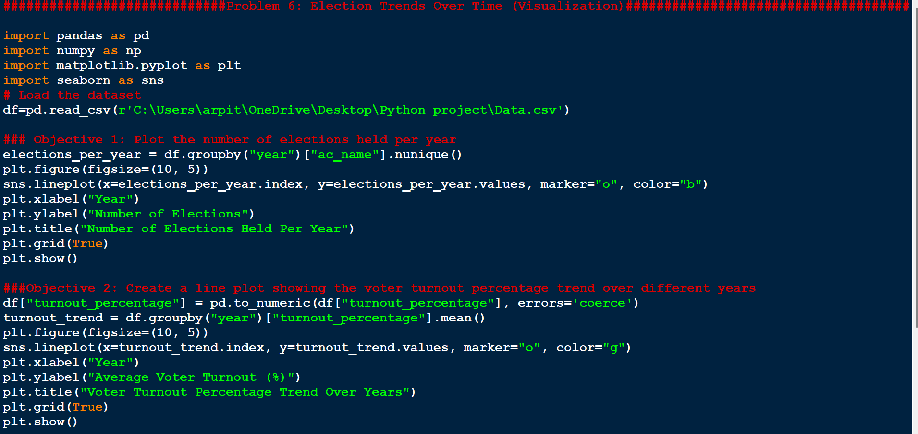

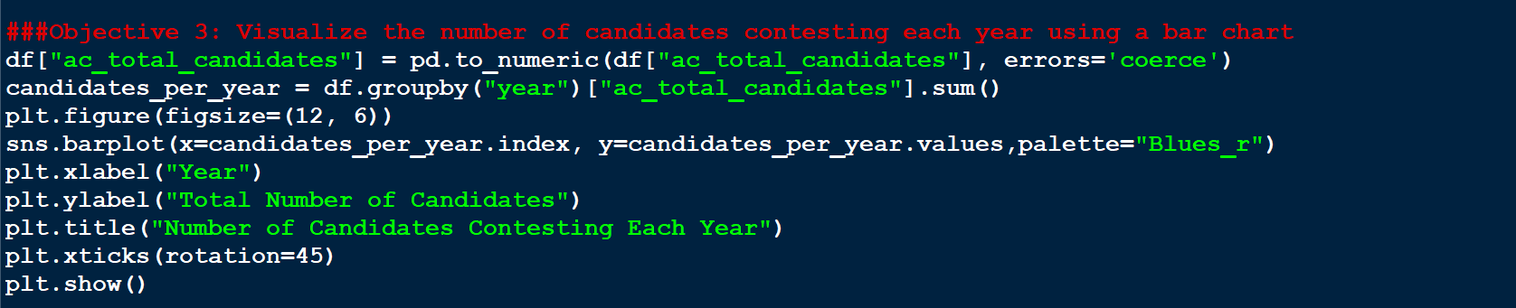

#############################Problem 6: Election Trends Over Time (Visualization)#############################################

import pandas as pd

import numpy as np

import matplotlib.pyplot as plt

import seaborn as sns

# Load the dataset

df=pd.read_csv(r'C:\Users\arpit\OneDrive\Desktop\Python project\Data.csv')

### Objective 1: Plot the number of elections held per year

elections_per_year = df.groupby("year")["ac_name"].nunique()

plt.figure(figsize=(10, 5))

sns.lineplot(x=elections_per_year.index, y=elections_per_year.values, marker="o", color="b")

plt.xlabel("Year")

plt.ylabel("Number of Elections")

plt.title("Number of Elections Held Per Year")

plt.grid(True)

plt.show()

###Objective 2: Create a line plot showing the voter turnout percentage trend over different years

df["turnout_percentage"] = pd.to_numeric(df["turnout_percentage"], errors='coerce')

turnout_trend = df.groupby("year")["turnout_percentage"].mean()

plt.figure(figsize=(10, 5))

sns.lineplot(x=turnout_trend.index, y=turnout_trend.values, marker="o", color="g")

plt.xlabel("Year")

plt.ylabel("Average Voter Turnout (%)")

plt.title("Voter Turnout Percentage Trend Over Years")

plt.grid(True)

plt.show()

###Objective 3: Visualize the number of candidates contesting each year using a bar chart

df["ac_total_candidates"] = pd.to_numeric(df["ac_total_candidates"], errors='coerce')

candidates_per_year = df.groupby("year")["ac_total_candidates"].sum()

plt.figure(figsize=(12, 6))

sns.barplot(x=candidates_per_year.index, y=candidates_per_year.values,palette="Blues_r")

plt.xlabel("Year")

plt.ylabel("Total Number of Candidates")

plt.title("Number of Candidates Contesting Each Year")

plt.xticks(rotation=45)

plt.show()

**Output:**

